Research Software: Unleashing the Potentials of Google Assistant, 5G, Deep Learning, Big Data, NoSQL Technologies for Efficient Research in Graduate School

Emmanuel Ameh

01/08/2019

Research Software: Unleashing the Potentials of Intelligent Personal Assistants, 5G, and Deep Learning Technologies for Efficient Research in Graduate School

**Introduction to the Software Development Project**

Beginning a software development project is a task that must be handled with tact. It requires careful planning and paying attention to the fine details of the Software Development Life Cycle (SDLC).

According to Wang,

“The potential of Human-Machine Partnerships is immense. Humans have partnered with

machines for centuries but thanks to Machine Learning we are entering a new era, full of

possibilities. By offloading more, we’ll be able to focus on what humanity does best.” (2019).

Partnering with Jim and Joe, we teamed to decide on creating a new computer software to service as an Intelligent Personal Assistant for graduate school students. In the following assignment paper, the business need being fulfilled in addition to the new product in proposal are described. The rationale for selecting the product for the target purchasing-audience will be discussed. Motivation for its success will also be included in the discussion. Technological principles and concepts the software will use to include Intelligent Personal Assistant, 5G, and Deep Learning Technologies will be considered by this researcher.

**Business Need**

Time is the most essential commodity in the life of a graduate student, especially doctoral students. There is a need for improving on the graduation rates of graduate schools especially for doctoral programs in Science, Technology, Engineering and Mathematics (STEM). Several research results point to the fact that more than 50% of those beginning a doctoral program are not able to obtain the final degree for several reasons to include time management. Low turnover rates deplete a nation’s financial resources and lengthier programs lead to fewer years in the workforce and hence the economy in general is impacted. Graduates from technology related programs may find out that the technology that was booming when they started its graduate school program is no longer sourced-for, five to six years down the line. In some cases, graduates may have to retrain in another technology to make ends meet, all due to the technological revolution of the twenty-first century. It’s about time the potentials of Intelligent Personal Assistants, 5G, Deep Learning, and AWS Technologies are explored for robust and efficient research in graduate schools across the United States.

**Product Proposed**

A multifaceted software product for gathering research materials based on voice-input-question similar in functionality to the Google Assistant, compiling the related references, formatting references in APA format, crawling the web’s databases for best suited materials using Deep Learning, and AWS Technologies, with voice-to-text capabilities similar to Dragon software and outputting the results to mobile devices such as laptops, PDAs, mobile phones, etc. with data or wireless connection. The software will be downloadable only by graduate students and proof will need to be shown before software is downloaded from the company’s website directly unto the phone.

**Rationale for Product**

Time is of essence in graduate school. Many students, especially graduate students will be glad to have such a software to reduce the workload and have more time for other important research activities such as publishing. The search function to gather research material can be time consuming and sometimes may consume up to half of the time consumed in preparing a research paper. Although it has improved considerably over the years, there is still room for improvement. In the twentieth century, the university brick-and-mortar library was the go-to place for acquiring research data and information. Then came the internet libraries from the latter part of the twentieth century, where scholar could find some of their academic materials in online repositories and other materials as paperbacks in on-the-ground libraries. Today there are well equipped online libraries with millions of volumes on any research topic one can think of.

**Why Product will be successful**

The product will be successful because it will be new on the market, and it is also innovative. Apart from it being innovative, a feature which will appeal to many students both young and old, it will be placed at an affordable price of $250. Another success point is that it will be well marketed in social media circles, on university campuses and on television. The high-quality standard of the product is another selling point for this innovative product. Another selling point includes its capability to reduce the time spent gathering online research resources by some 80% to 90%. It will also reduce errors where students find the wrong materials which are not suitable to the research. Will properly trained algorithms using Deep Learning techniques the search results will always be on point together with relevant APA-formatted references.

At certain times when students go online to put research resources together, they all-to-often get distracted by unrelated materials on other websites. This is a procrastinating point which sometimes does not help keep students focused until after some minutes or hours of accessing other information which may not be deemed important for the research. Cutting that aspect of time-wasting by using the Intelligent Personal Assistant, will save students a lot of time behind the screen and subsequently a lot of time which can be channeled to the workplace after graduation. be very much appreciated by most students.

**Software Project Planning**

According to Dawson and Dawson,

“Project planning for Software Design involves estimation about the cost, amount of effort, number of resources, and amount of time involved in building a specific software product or software system). Software Project Managers are at the forefront of building the plan.” (2014).

Our team will make use of information accumulated from software engineers, customers, software metrics data, collected from previous projects. In the above project proposal, project risks will be considered and calculated in addition to considering the software project’s complexity before arriving at the final estimates. In the following image, Software Developments Process inputs to generate a software product output with defined scope and quality are displayed.

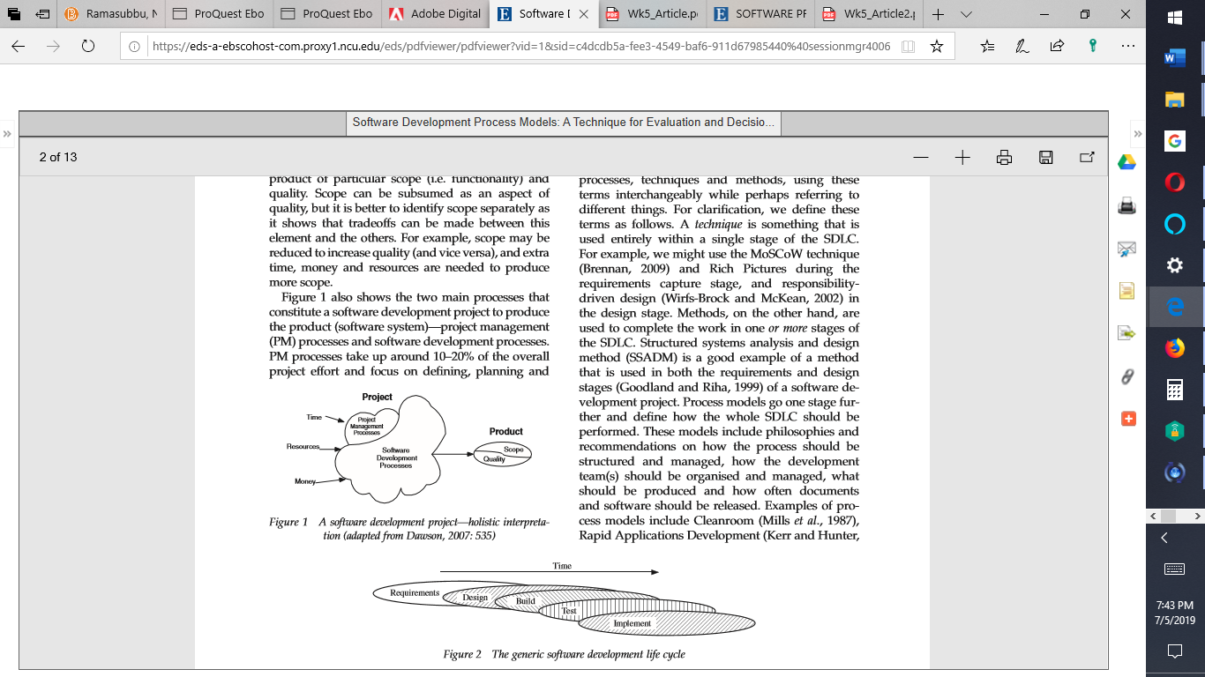

*Figure 1.* Software Development Project. Adapted from Dawson (2007)



*Figure 2.* The generic software development life cycle. Adapted from Dawson (2007).

The following will be needed as part of the project requirements to include Human Resources, Money, Time, Logistics, and Data Requirements.

**Technologies to be used**

The technologies to be applied include Intelligent Personal Assistant, 5G, Deep Learning, and Amazon AWS.

**5G for super-fast search results**

More recently under further development, 5G has the motive of improving on 4G technology. Some of the most noted improvements include low latency, higher connectivity-density, tremendously fast data-rates, and many significant improvements (Freund, 2019; Zhang et al., 2018). Other improvements in the works include improved wireless coverage, improved battery-consumption, and device-to-device communications. Maximum 5G speeds are targeted at 35GB/sec about 35-times faster than their 4G counterparts (Cheng, 2017). The programming for the IPA will be done in conjunction with high-speed internet in the 5G domain, for research results to be super-fast with no delays or latency, and high-throughputs.

**Python for Intelligent Personal Assistant Programming**

The programming language in which the Intelligent Personal Assistant (IPA) is built is as important as the language the IPA understands (Raj, 2019). Due to the programming language’s versatility, Python would be my first choice for coding the IPA. With its consistent language and syntax, it is also ideal for new programmers entering the field of programming. Python also has expanded into scientific computing whilst encouraging open-source libraries paving the way for Research and Development (R&D) benefits.

The Python language is the bedrock of Natural Language Processing (NLP) and Machine Learning. C++ is a very fast language with lots of library support such as Torch and TensorFlow however it lacks the magnitude of resources which Python has. Java Scripts and Java both have some capabilities with reference to Machine Learning (ML). Java programmers may rely on Machine Learning packages and on a plethora of libraries for JavaScripting. This may be great when applied to smaller datasets and simpler analysis but not suitable for larger datasets which Python’s libraries can readily handle.

C++ programming language is a highly performance-savvy language. C++ is the go-to option for fast completion of projects and also offers higher-levels of abstraction. Python has Artificial Intelligence Markup Language (AIML) functionality making it easier for the composition of syntax for IPA features that are complex. Quite apart from its extensive library, Python presents a highly interactive and modular code with the highest compatibility possible across several multiple platforms. The Natural Language Toolkit (NLTK) within Python caters to the API.ai technologies necessary for creating the IPA. By examining manually annotated data, IPAs can be trained for using NLTK. The training will consist of three different lists of long questions, short questions, and medium-length questions. The research results improve with more data infused into the training.

**Deep Learning**

In designing the IPA, we’ll train Deep Learning Models for the IPA on an Amazon EC2 instance using the AWS-Deep Learning Containers. We will in addition download Git to run the training and testing models. AWS Deep Learning Containers are Docker images that are pre-installed with deep learning frameworks to make it easy to deploy custom machine learning environments quickly by letting developers skip complicated processes of building and optimizing environments right from the beginning ( ). Using AWS DL Containers, developers and data scientists can quickly add deep learning to their containerized applications deployed on Amazon EKS, Amazon Elastic Container Services and Amazon EC2.

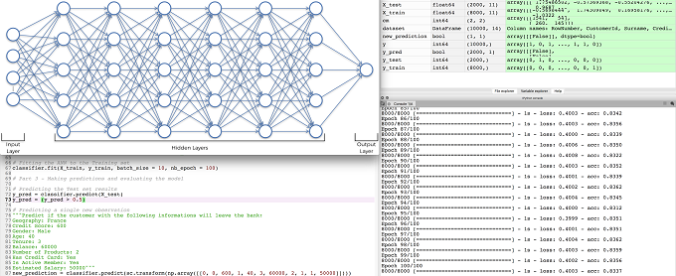*Figure 2*. Sample Deep Neural Network showing input, hidden and output layers with Python code directly underneath. Output is on the right-hand side of image.

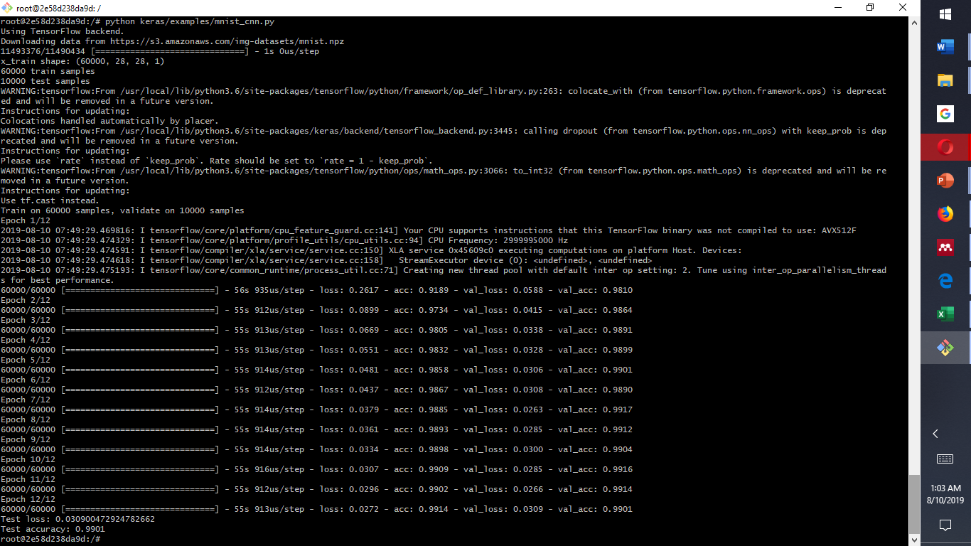

Figure 2. Example Deep Learning Model with 60000 train samples and 10,000 test samples using TensorFlow backend in AWS. Our model will be trained with 50,000 train samples and 25,000 test samples to produce high efficiency in search results.

**Intelligent Personal Assistants such as Google Assistant**

IPAs have become very popular in the lives of many customers. Google Assistant like many other personal assistants is an AI-driven virtual assistant (VA) created by Google and it is available on smart home and mobile devices (Strayer, Cooper, Turrill, Coleman, & Hopman, 2017). Google Assistant unlike its predecessor virtual assistant, Google Now, has the capability of engaging in two-way conversations. Google Assistant debuted in 2016 in combination with the messaging application known as Allo (Santos, Rodrigues, Casal, Saleem, & Denisov, 2016). It was merely part of the pixel and pixel XL smartphones, but later got deployed onto other Android devices such as Android Wear in early 2017, and as a stand-alone application on the i-Operating System (iOS). Google Assistant is under enhancement to further support a variety of devices to include third-party smart-home appliances and smart-cars.

Currently, Google Assistant is installed on more than 500 million devices. The natural voice is the medium of contact or primary interaction mode with Google Assistant although computer keyboard inputs are also acceptable (Santos et al., 2016). Functions of the Assistant include Internet searches, event-scheduling, alarms, adjustment of hardware-settings on user’s devices and information-display from users’ Google accounts (Simonite, 2019). Google Assistant will also in the future be used for object-identification, visual-information-gathering through camera, product purchase, and money transfers, in addition to song-identification.

**Basic Technologies for building the Intelligent Personal Assistant**.

“Api.ai” is a service allowing developers to build speech-to-text, natural language processing, artificially intelligent systems that can be trained up with customized functionality (SAS Institute Inc., 2019).  It will be employed in the development of the voice assistant. In our voice assistant we will make use of Voice/speech to text (STT). It is the process of converting speech into digital data, for instance text data. The voice could be in a file format or a voice stream and CMU Sphinx will be used for its processing (Moussalli & Cardoso, 2019). The Intelligent tagging and decision-making component serve for the interpretation of the user's request. For example, the user may ask: 'What are the features of a good programming language? The technology will tag the key words and suggest up to the number of references required between 2015 and 2020. It will also respond with up to a maximum of five most relevant paragraphs in each of the references. This will be the output within a selected application on the mobile device such as Microsoft Word.

Image recognition will not be featured in this application. Noise from others talking around, from blurring autos, electrical appliances etc. will be filtered by the noise controlling technology to promote accurate voice recognition and enhance the overall user-experience (Maruti Techlabs, 2019b). Voice-biometrics will also be programmed in for identifying the voice and whether to carry on with the search task. This will reduce error task-execution from, for example television speakers (Maruti Techlabs, 2019a). The text interface is what the user sees as a result of the request. One has to decide what visual representation they will see on screen. The text and voice data will both be processed directly on an http information server. The image below, depicts the schema working with participating servers.

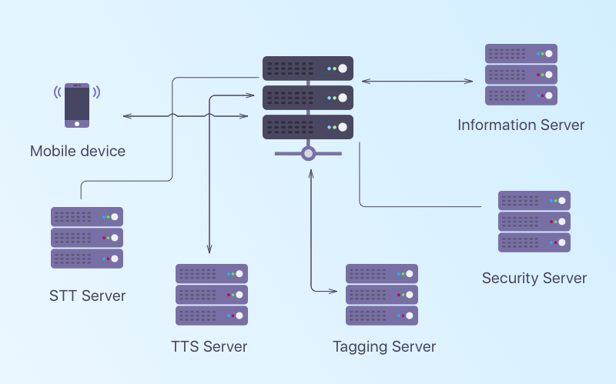

*Figure 3.* Intelligent Personal Assistant’s architecture. Retrieved from https://www.cleveroad.com/blog/how-to-create-virtual-assistant-apps-like-siri-and-google-assistant

Summary and Conclusions

Intelligent Personal Assistants are a twenty-first century technological innovation that have become popular in several ways, from Amazon’s Alexa, to the Google Assistant, and to the iPhone Siri (Quantumrun, 2019; Maruti Techlabs, 2019b; Book, 2018; Andriole, 2017). They are used by millions of customers to make life much easier and do away with redundant searches on the Internet. In the above assignment paper, the business need that will be fulfilled was addressed. This was in addition to the vivid description of the new product in proposal. The rationale for selecting the product for the target purchasing-audience was discussed at length. The motivation for its success was not left out of the discussion. The technological principles, and programming concepts the software we will use to include Intelligent Personal Assistant, 5G, Deep Learning Technologies, and Amazon Web Services (AWS) were considered by this researcher for further implementation.

References

Andriole, S. (2017). There Will Be 30 Technology Companies In 2030, 10 in 2050, and then there will be none. Retrieved from https://www.forbes.com/sites/steveandriole/2017/05/25/there-will-be-20-technology-companies-in-2030-10-in-2050-and-then-there-will-be-none/#412a643a132b

Book, A. (2018). I compiled a list of Tech’s “Next Big Things” so you wouldn’t have to: 2030 will be weird. Retrieved from https://hackernoon.com/i-compiled-a-list-of-techs-next-big-things-so-you-wouldn-t-have-to-d98ea9cac4bd

Freund, R., Haustein, T., Kasparick, M., Mahler, K., Schulz-Zander, J., Thiele, L., ... & Weiler, R. (2019). 5G Data Transfer at Maximum Speed. In *Digital Transformation* (pp. 87-107). Springer Vieweg, Berlin, Heidelberg.

Maruti Techlabs (2019a). What is a Conversational UI and why does it matter? Retrieved from https://chatbotsmagazine.com/what-is-a-conversational-ui-and-why-it-matters-de358507b9a2

Maruti Techlabs (2019b). How is Natural Language Processing applied in business? Retrieved

from https://www.marutitech.com/how-is-natural-language-processing-applied-in-business/

Moussalli, S., & Cardoso, W. (2019). Intelligent personal assistants: can they understand and be understood by accented L2 learners?. *Computer Assisted Language Learning*, 1-26.

Nekovee, M. (2018). Opportunities and Enabling Technologies for 5G and Beyond-5G Spectrum Sharing. *Handbook of Cognitive Radio*, 1-15.

Quantumrun (2019). State of technology in 2030: Future Forecast. Retrieved from https://www.quantumrun.com/future-timeline/2030/future-timeline-subpost-technology

SAS Institute Inc. (2019). Natural Language Processing (IoT): What it is and why it matters. Retrieved from https://www.sas.com/en_us/insights/analytics/what-is-natural-language-processing-nlp.html#howitworks

Santos, J., Rodrigues, J. J., Casal, J., Saleem, K., & Denisov, V. (2016). Intelligent personal assistants based on internet of things approaches. *IEEE Systems Journal*, *12*(2), 1793-1802.

Simonite, T. (2019). Google may have finally made a truly usable voice assistant. Retrieved from https://www.wired.com/story/google-made-truly-usable-voice-assistant/

Strayer, D. L., Cooper, J. M., Turrill, J., Coleman, J. R., & Hopman, R. J. (2017). The smartphone and the driver’s cognitive workload: A comparison of Apple, Google, and Microsoft’s intelligent personal assistants. *Canadian Journal of Experimental Psychology/Revue canadienne de psychologie expérimentale*, *71*(2), 93.

Wang, A. (2019). Realizing 2030: A survey of future technologies and digital transformation. Retrieved from https://www.delltechnologies.com/en-us/perspectives/realizing-2030.htm

Zhang, Y., Lopez, J., Tang, J., Liang, Y. C., & Zhang, X. (2018). Wireless Big Data: Technologies and Applications. *IEEE wireless Communications*, *25*(1), 10-11.